**Presenting Neighborhood of London and New York**

**Clustered Venues of Greenwich and Kensington**

1. Visualize of London and New York on the maps

* London

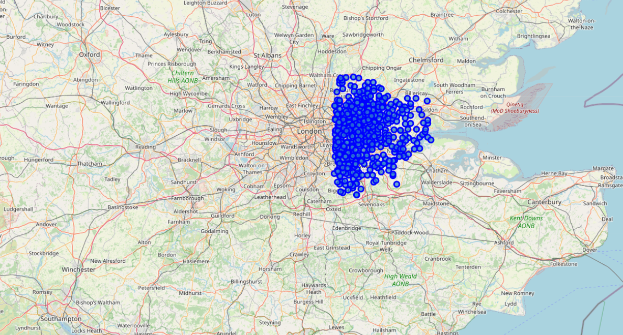

* New York

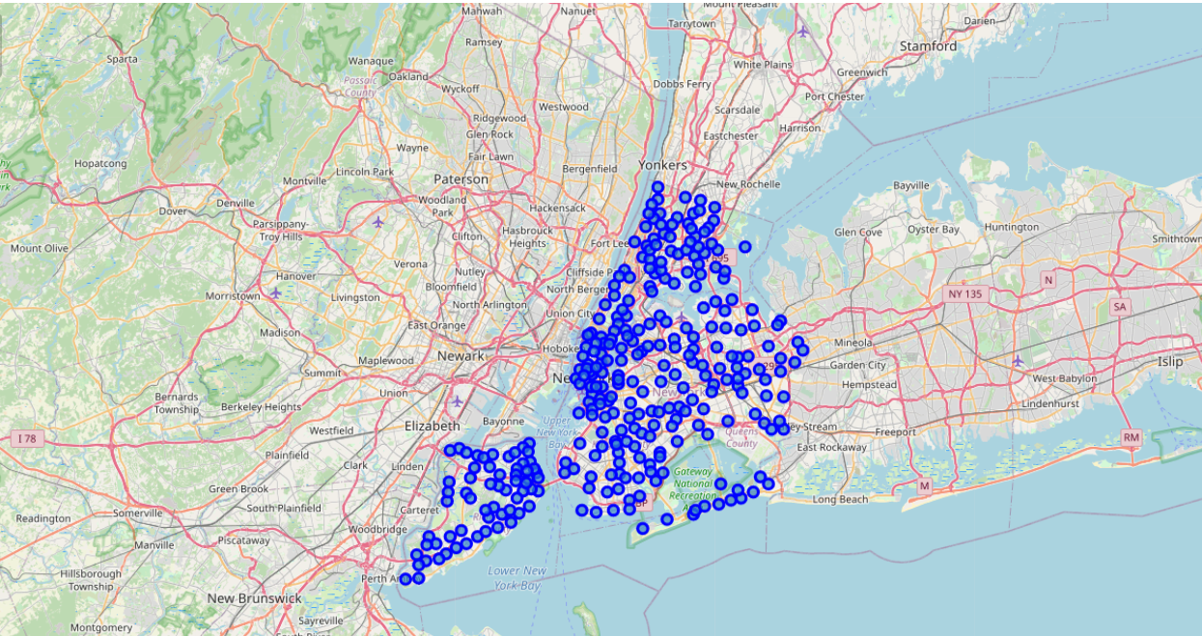

1. Total number of travelers, total number of restaurants and the total number of restaurants on each city located in London and New York respectively

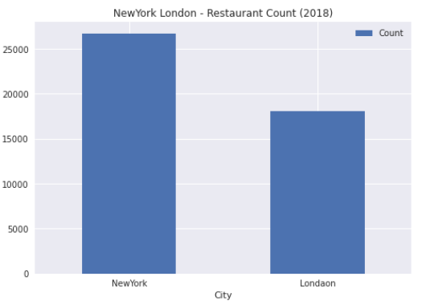

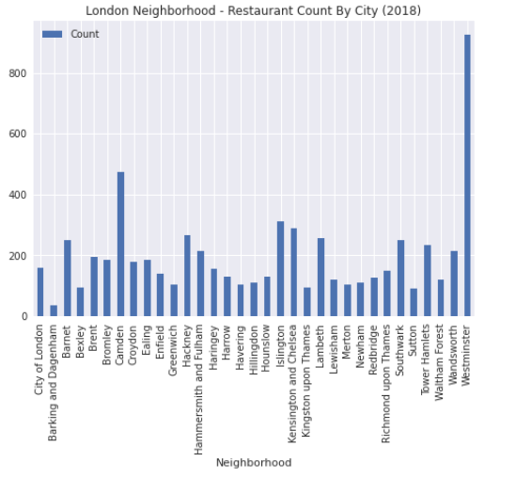

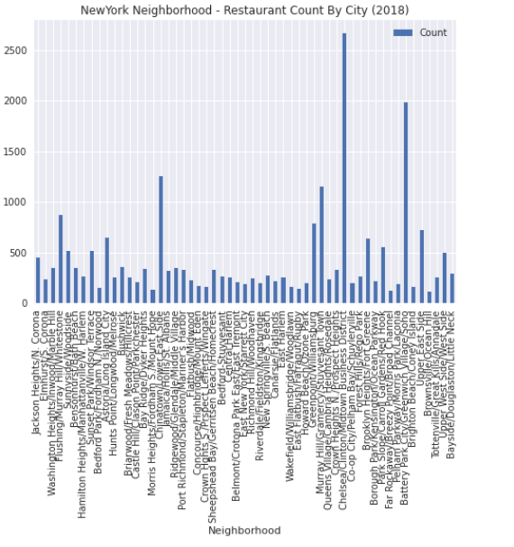

1. Visualize of Venues clustered in Greenwich.
2. The original Greenwich map.

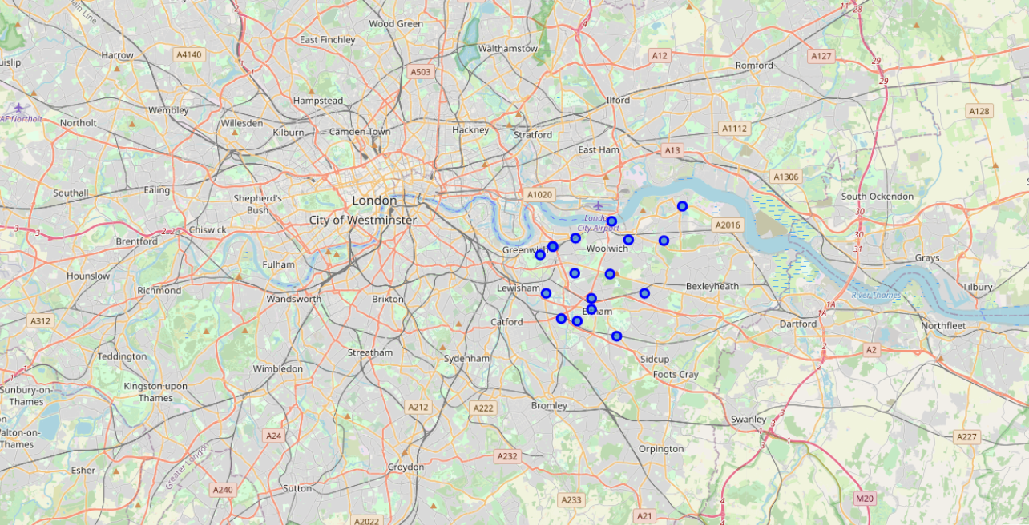

1. The cluster Greenwich map

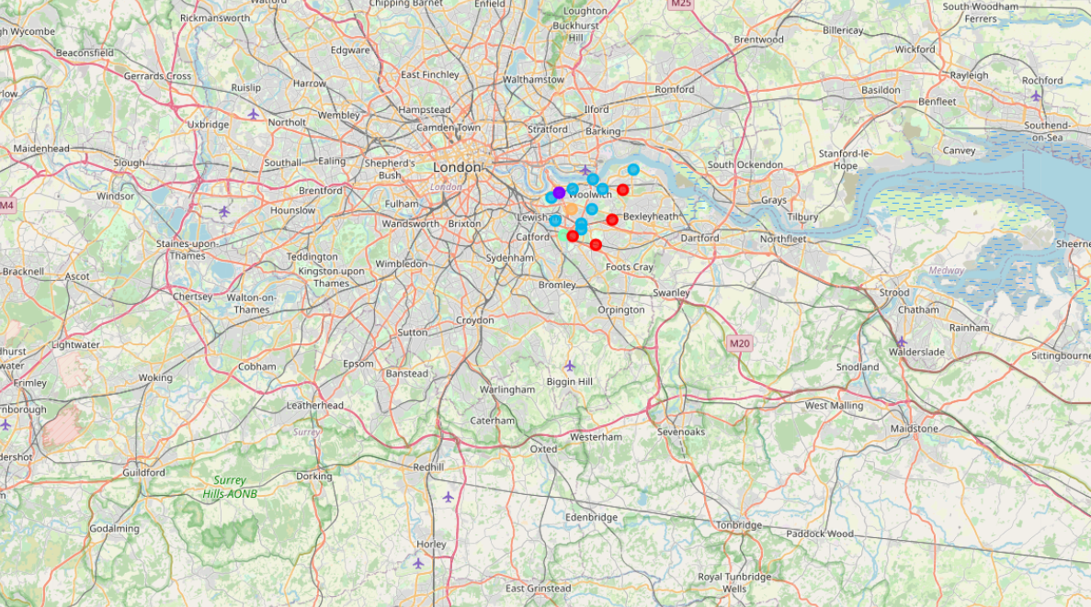

1. The present of each Greenwich cluster

Cluster 1:

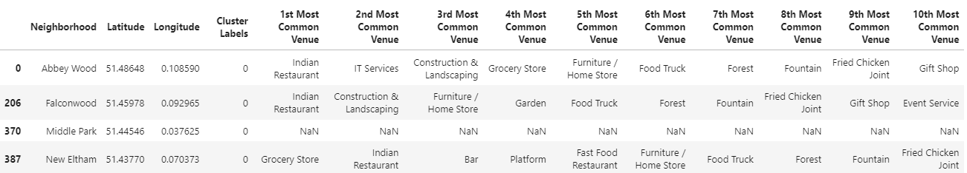

Cluster 2:

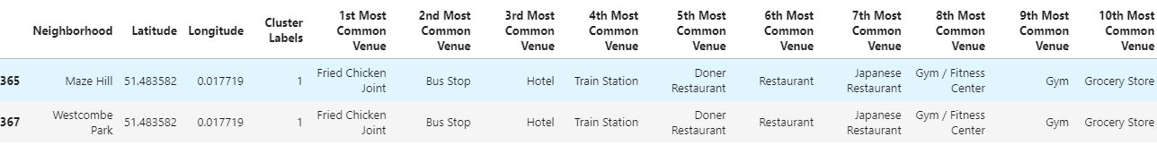

Cluster 3:

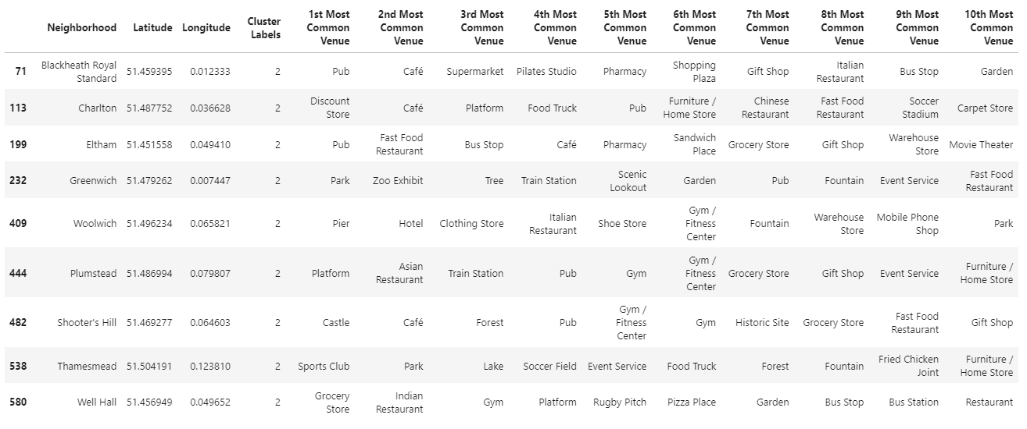

Cluster 4:



Cluster 5:



1. Visualize of Venues clustered in Kensington.

a) The original Kensington maps

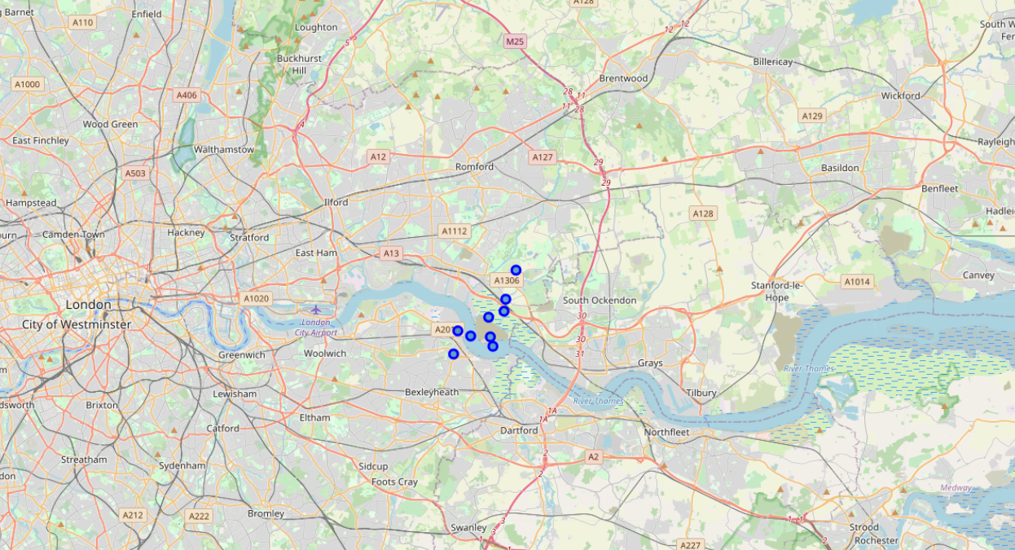

b) The cluster Kensington map

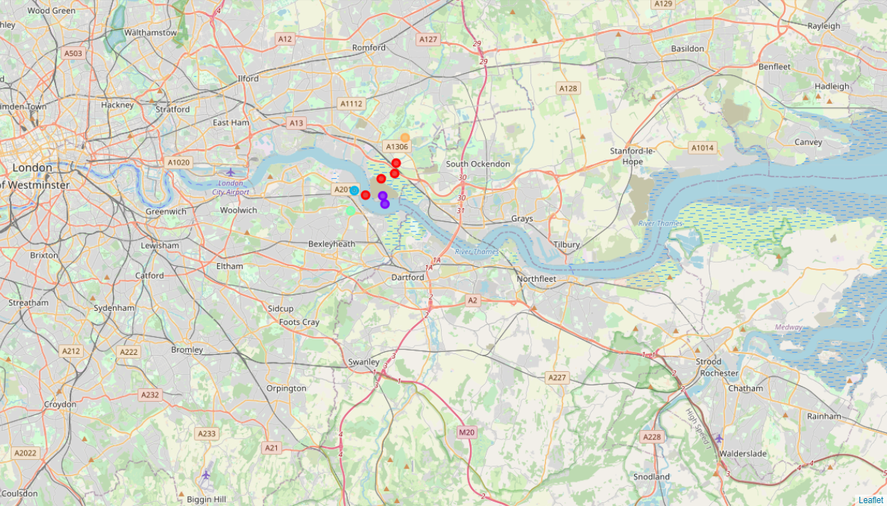

1. The present of each Kensington cluster

Cluster 1:

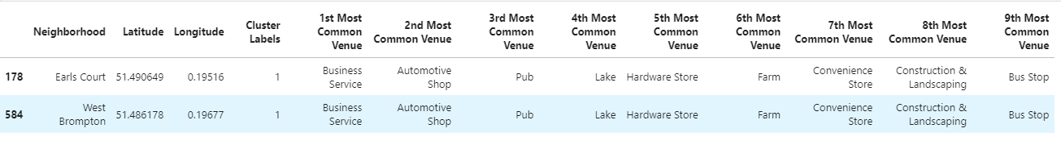

Cluster 2:



1. Conclusion

The map shows London and New York are two big cities in the world. We have Chinatown in New York occupied the greatest number of restaurants in the city and that of London is Westminster. By comparing Greenwich and Kensington are two cities in London, based on data, it shows Kensington should be the place which is easier to open a totally new business.